

**Electronic store**

**Data Analysis**

**Project**

Table of contents

01 Introduction

Objective, Track Relevance**,**

Expected Outcomes,

Description of Dataset

04 Metrics and Deliverables KPI , more important metrics

02 ProjectProposal

Title**,** Team Members**,** Problem Statement**,** Proposed Solution, Scope and Limitations

05

Data Preparation and Exploratory Data Analysis (EDA)

Data Collection, Data Cleaning and Preprocessing, Exploratory Data Analysis

03

Project Plan

Milestones, Task Breakdown,

Resources Needed, Risk Management

07 Conclusion

06 Presentation

Create Presentation Slides,

Project Report

Introduction **• Objective**

The main objective is to analyze the sales data of an electronics retailer to identify key trends, customer purchasing behavior, and product performance. This project aims to provide actionable insights to improve sales strategies, optimize inventory, and enhance customer satisfaction.

**• ScopeofWork**

The project involves collecting and cleaning historical sales data, conducting exploratory data analysis (EDA), identifying key performance indicators (KPIs), and generating visual reports using Power BI.

**•** Expected Outcomes

▪ A comprehensive dashboard displaying sales performance by region, product, and time. ▪ Customer segmentation based on purchasing patterns.

▪ Sales trend predictions to assist in future decision-making.

▪ A document inform leader all information to enhance understanding the insights.

**Description of Dataset**

**Global Electronics Retailer**

**Sales data for an electronics retailer, including tables containing information about transactions, products, customers, stores and currency exchange rates.**

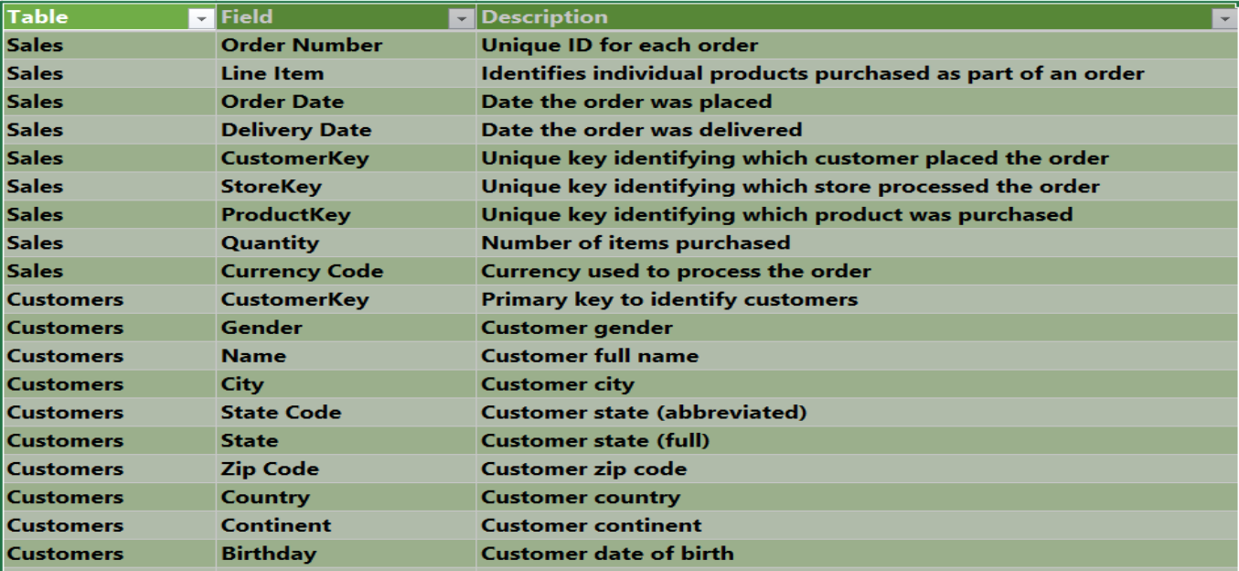

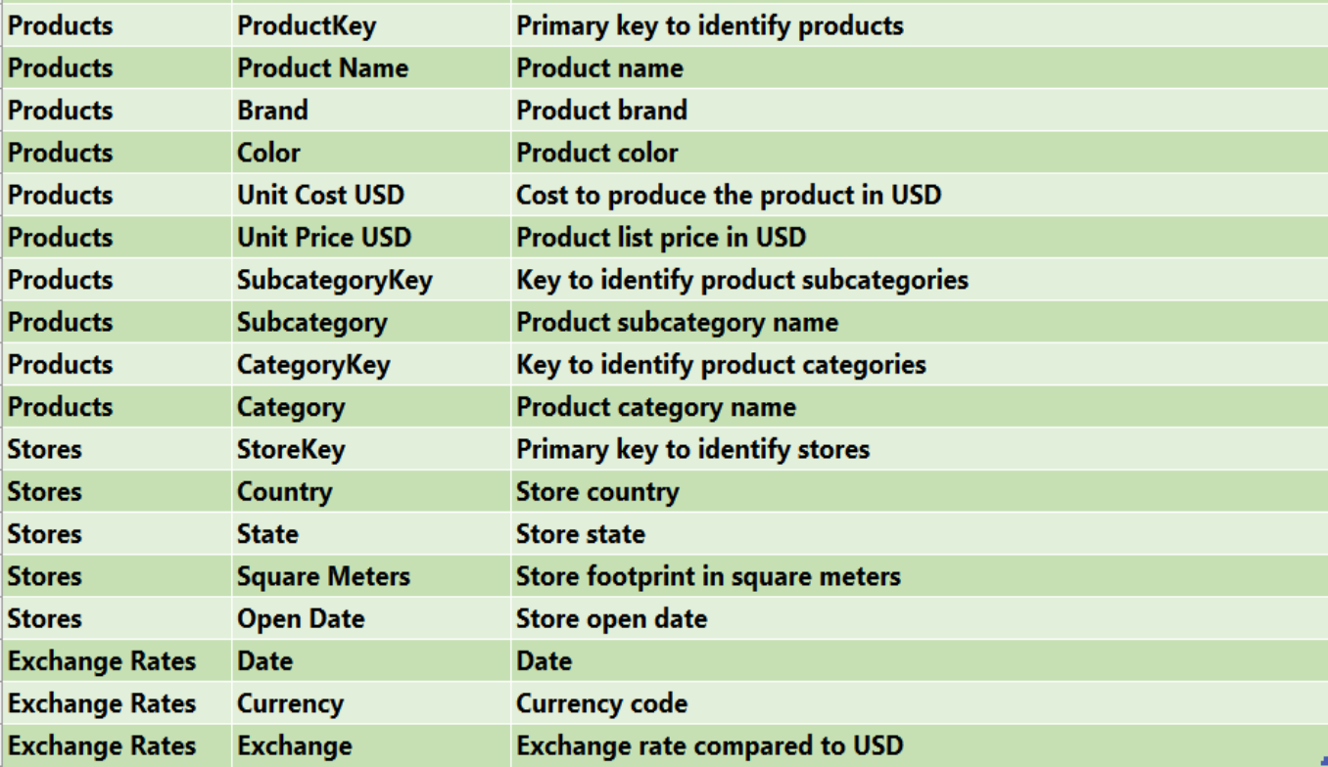

Project Proposal

**• Title**

**Electronics Retailer Sales Analysis**

**• Team Members**

Mohamad Gamal Ibrahim, Muhammad Sameer, Wafaey Mohammed, Khaled Mohammed

**•** Problem Statement

Electronics retailers often struggle with managing large volumes of sales data, which can make it difficult to identify sales trends and optimize operations. This project seeks to address these challenges by analyzing sales data to uncover insights that can drive better decision-making in inventory management, marketing strategies, and customer targeting.

**•** Proposed Solution

Technologies Used:

• Python and SQL for data cleaning and analysis

• Power BI for data visualization

• Excel for data collection and preliminary analysis

• Power Point for preparing a document.

Solution Architecture:

▪ Data collection from sales records, inventory, and customer databases.

▪ Data processing and analysis using Python, Power Query for cleaning, manipulation, and feature extraction. ▪ Data visualization using Power BI for presenting insights and KPIs to stakeholders.

**• Scope and Limitations**

• Scope

1.Data Integration and Management:

• Data cleaning and transformation processes to ensure consistency and accuracy.

• Handling data related to product sales, customer demographics, and marketing activities.

2.Sales and Inventory Analysis:

Analysis of historical sales trends to identify seasonal patterns, high-demand periods.

• Limitations

Data Availability and Quality:

• Historical data may be limited or incomplete, which can hinder the accuracy of trend analysis and forecasts.

Project Plan

**• Milestones**

1-Project Initiation (Week 1)

2- Data Collection and Integration (Week 2 )

3- Determine KPI and Pages of Dashboard (Week 3)

4- Dashboard and Report Development (Week 4)

5- User Documentation (Week 5)

**• Task Breakdown**

**1-**Project Initiation :

• Define project goals and scope.

• Identify key stakeholders and their roles.

• Gather initial requirements from Data and some websites.

• Prepare project plan and timeline.

**2-Data Collection and Preparation**:

• Identify data sources (Data website).

• Extract historical sales.

• Clean, normalize, Merge and integrate data into a unified database for analysis.

3- Determine KPI and Pages of Dashboard :

• Analyze key business metrics: sales by product category, revenue, profit margins. • Determine KPIs for stakeholder.

4- Dashboard and Report Development:

• Design key performance indicators (KPIs) in dashboards.

• Develop customizable, real-time reports and dashboards in Power BI.

• Implement category-wise revenue, customer segmentation, and sales performance reports.

5- User Documentation:

• Build Document for project with power point

Metrics and Deliverables

• Determine Measurements :

• Total Revenue

• Total Cost

• Profit Margin = (Total Revenue - Total Cost) / Total Revenue

• Average purchase value = Total sales / number of customers or transactions

• Ranking products based on sales and store and month and city

• Average Order Value (AOV) = Total Revenue / Number of Orders

• Revenue Growth Rate measures the percentage increase in revenue over a specific period • Ranking category and subcategory

• Total Orders

• Total Items Sold

• Total Customers

• Average Quantity per Order

• Filters on Country, Date.

• Currency Code

Preparation Data & Analysis (EDA)

• Data Collection :

• Gather relevant datasets from online sources, public databases.

• Data Cleaning and Preprocessing :

• Read data into SQL Server and Power BI and ensure the data is accurate and data types of fields. • Implement data cleaning techniques in Python and Power BI to handle missing data, duplicates, and inconsistencies.

• Make Date Table in SQL Server from some column in existed table for using in further analysis.

• Exploratory Data Analysis (EDA):

• Use Python( NumPy, Pandas, Matplotlib, Seaborn) statistical tools and visualizations to explore the dataset and generate summary statistics to understand the data distribution and relationships.

Data Modeling SQL Server

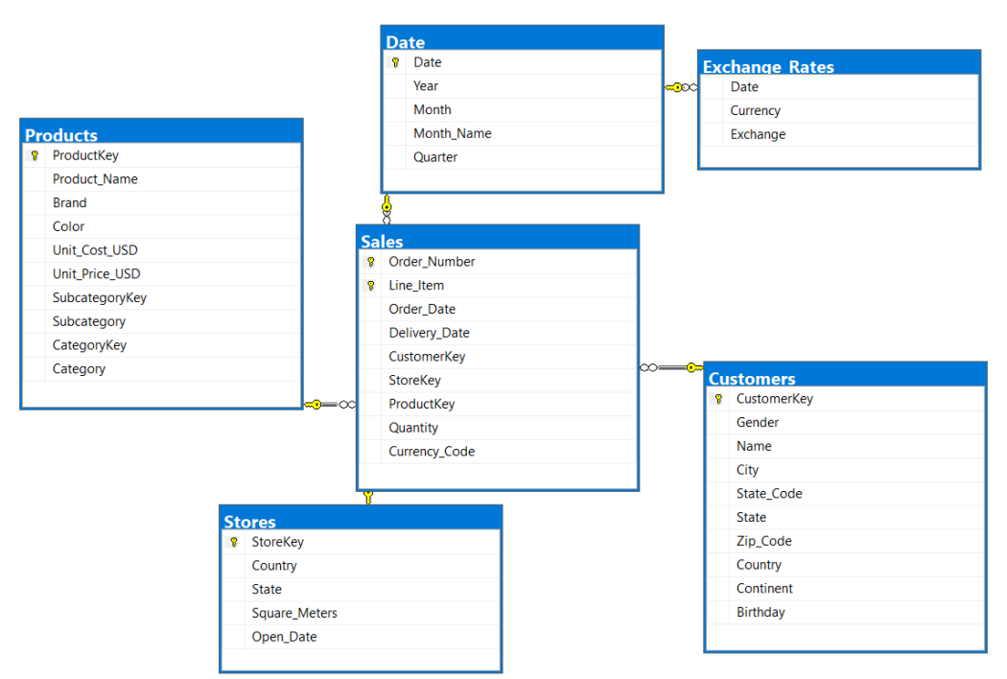

• Data Modeling From Power BI after creating measures aggregate.

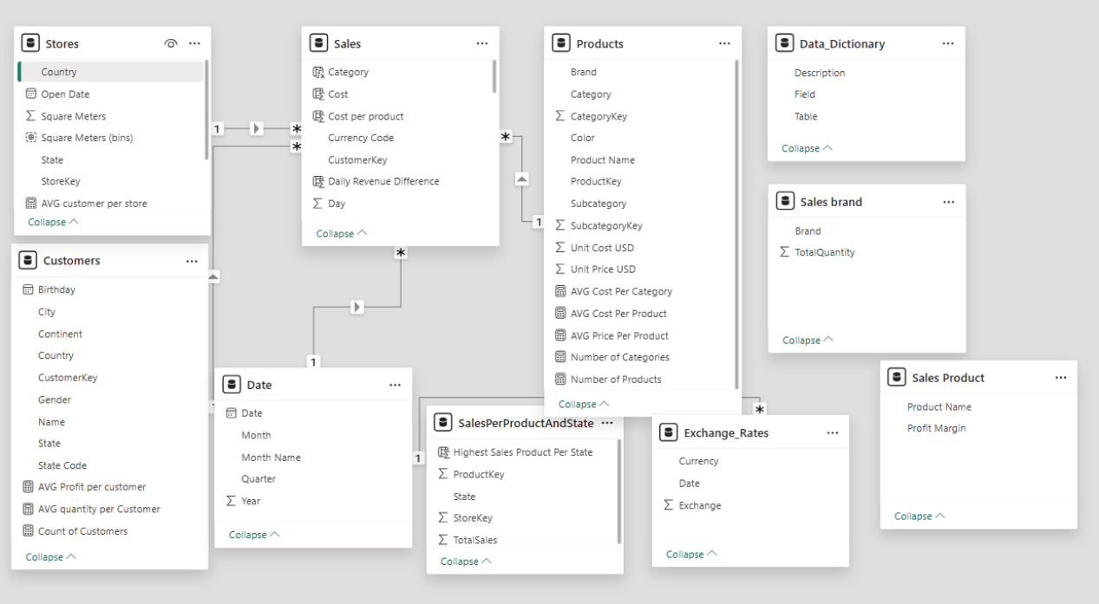

• Data Cleaning and Preprocessing :

Creating Date Table In SQL Server

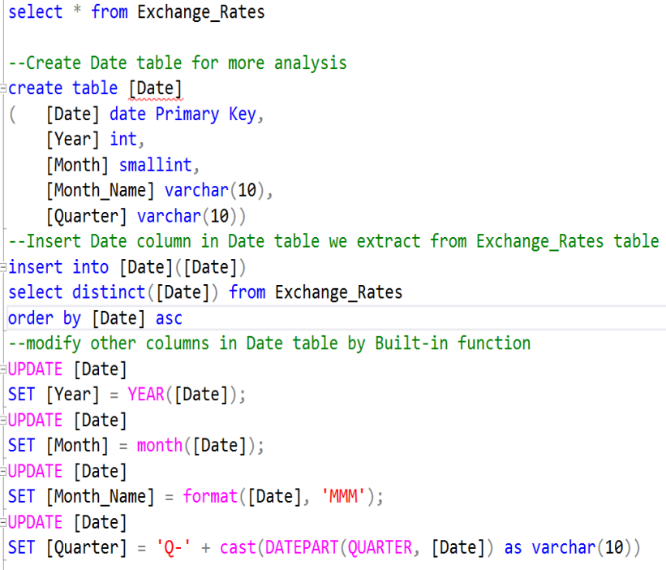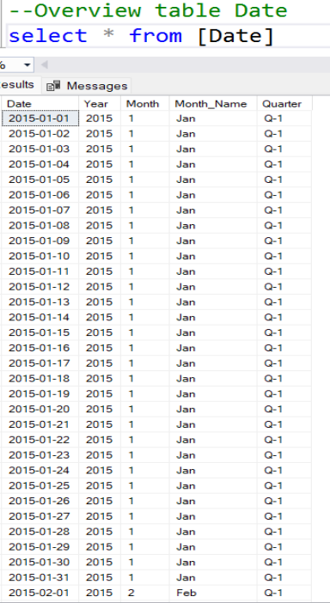

• Exploratory Data Analysis (EDA): creating visuals to extract insight from data in

python and get summary statistics

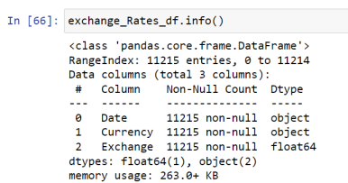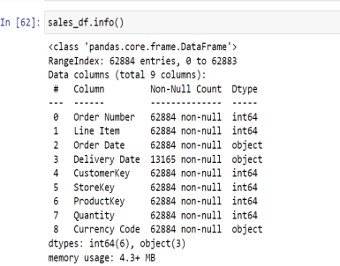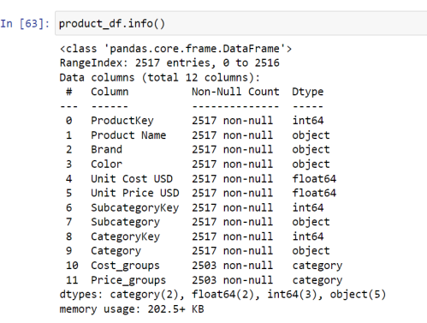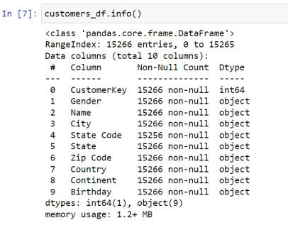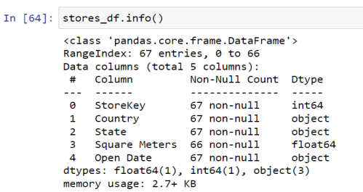

• Exploratory Data Analysis (EDA): creating visuals to extract insight from data in

python and get summary statistics

**The United States has the** 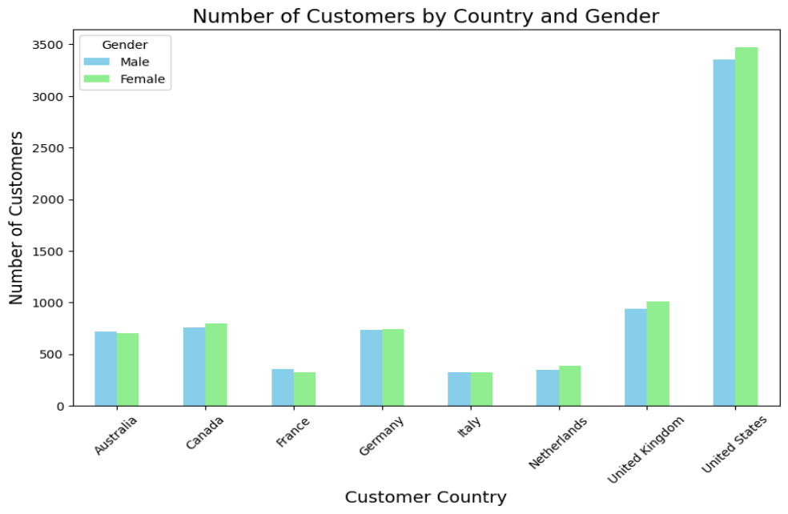

**highest number of customers,**

**followed by the United**

**Kingdom and Germany. For**

**most countries, the number of**

**male and female customers is**

**relatively similar. However, in**

**the United States, there are**

**significantly more female**

**customers than male**

**customers.**

**The age group with the highest number of people is 61+, followed by 31-45 and 46-60. The age groups 19-30 and 0-18 have significantly lower numbers of people.**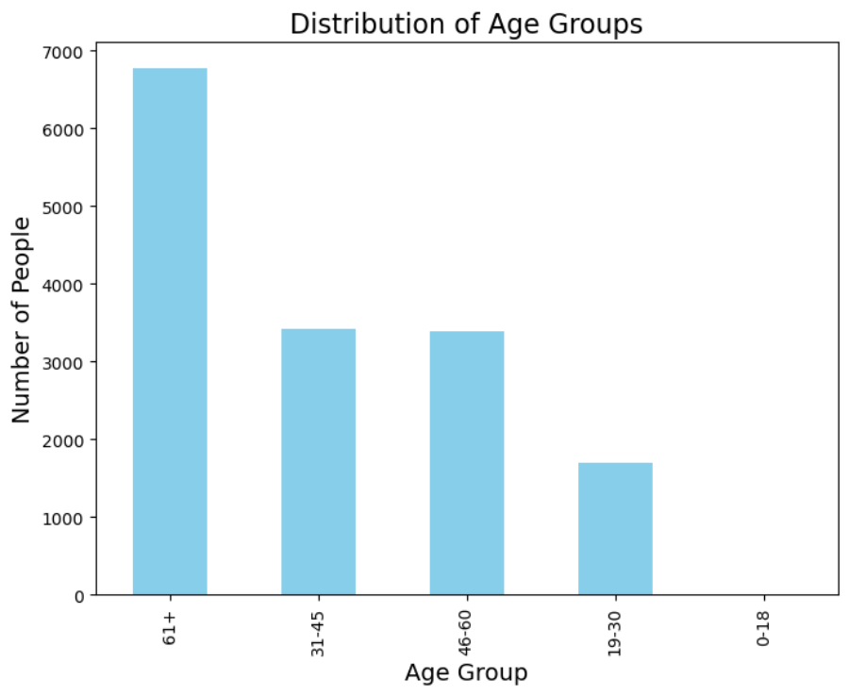



**Unit Cost Analysis:**

•The majority of products have a unit cost between $0 and $118.23. •There is a significant number of products with a unit cost between $118.23 and $235.98.

•The number of products decreases as the unit cost increases. •There are a few products with a unit cost above $1060.22.

**Unit Price Analysis:**

•The majority of products have a unit price between $0 and $356.40. •There is a significant number of products with a unit price between $356.40 and $711.85.

•The number of products decreases as the unit price increases. •There are a few products with a unit price above $2844.54. **Overall Analysis:**

•The distribution of unit cost and unit price is similar.

•The majority of products have a low unit cost and unit price. •There is a small number of products with a high unit cost and unit price. •The unit cost and unit price are not perfectly correlated. There are products with a low unit cost but a high unit price, and vice versa.

USD is the dominant currency: The total quantity of products sold in USD is significantly higher than any other currency. 

EUR and GBP also have significant sales: The total quantity of products sold in EUR and GBP is also relatively high. AUD, CAD, and other currencies have lower sales: The total quantity of products sold in AUD, CAD, and other currencies is much lower. Most products are sold in quantities of 1 or 2: The majority of products are sold in quantities of 1 or 2. Higher quantities are less common: Higher quantities, such as 3 or more, are less common



**The outliers in 'Unit Cost USD' are primarily high-end products like refrigerators and televisions, which have significantly higher costs compared to other products in the dataset. These products represent about 7.27% of the total products, indicating that they are a small but distinct group with higher costs.**

**Unit Cost Analysis:**

•The median unit cost is around 150 USD.

•The interquartile range (IQR) is relatively small, indicating that the majority of unit costs are clustered around the median.

•There are a few outliers on the right side of the plot, indicating that there are a few products with unit costs significantly higher than the majority.

•The distribution is skewed to the right, meaning that there are more products with higher unit costs than lower unit costs.

**Unit Price Analysis:**

•The median unit price is around 500 USD.

•The IQR is larger than the IQR for unit cost, indicating that the unit prices are more spread out. •There are a few outliers on the right side of the plot, indicating that there are a few products with unit prices significantly higher than the majority.

•The distribution is also skewed to the right, meaning that there are more products with higher unit prices than lower unit prices.

**Overall Analysis:**

•Both the unit cost and unit price distributions are skewed to the right, indicating that there are more products with higher costs and prices than lower costs and prices.

•The unit prices are more spread out than the unit costs, as indicated by the larger IQR for unit price. •There are a few outliers in both distributions, indicating that there are a few products with extremely high costs and prices.



**Presentation**



• **Overview Visualization**

**1. Description of the Dashboard**

This dashboard provides a comprehensive overview of **analysis** for an electronic store, displaying key metrics related to product sales, categories, profit margins, and sales trends over time. The dashboard is divided into multiple sections for better clarity:

**1.Total Orders: 26,000** orders have been processed, reflecting overall sales activity.

**2.Total Cost:** The company incurred **$7.31M** in costs to fulfill these orders.

**3.Total Revenue:** The store generated **$55.8M** in revenue, indicating a significant return on the costs. **4.Total Quantity Sold: 198,000** items have been sold in total.

**5.Average Quantity per Order:** Customers, on average, purchase 8 items per order.

**6.Average Shipping Days:** Orders take an average of **5** days to be delivered.

**Monthly Cost Trends:**

The line chart in the center displays the **average cost per month** ranging between $113 and $121. The cost fluctuates slightly, with the highest spike in March **($121.43)** and the lowest in June **($113.81).**

**Revenue and Quantity by Category:**

The bottom left **Tree Map** shows revenue distribution by category. Key categories are:

•**Computers (35%):** Leading in revenue, followed by:

•**Home Appliances (19%)**

•**Cameras (12%)**

• **Cell Phones (11%)**

Smaller shares are attributed to TV, Audio, and Music categories, each contributing between **6%** and **11%**. **Filter:** There are some filters for using (Country , Year, Quarter).

**2. Two lines charts**

The provided two lines charts show the average cost per unit sold and exchange rates over a year.

**Analysis of Average Cost per Unit:**

• **Trend:** The average cost per unit fluctuates throughout the year. There is a general upward trend from January to March, followed by a downward trend until August. The cost then increases again from September to December. • **Seasonal Patterns:** The fluctuations in average cost might be influenced by seasonal factors such as increased demand during certain periods, changes in production costs, or promotional activities.

• Can make drill down to display fluctuations over year for chart in dashboard.

**Analysis of Exchange Rates:**

• **Stability:** The exchange rates for all currencies against USD appear relatively stable throughout the year, with minor fluctuations.

• **Currency Appreciation/Depreciation:** Some currencies, such as AUD and CAD, show a slight appreciation against USD, while others, like GBP and EUR, remain relatively stable.

• **Impact on Costs:** Fluctuations in exchange rates can affect the cost of imported goods and materials. If the domestic currency weakens, it can lead to increased costs for imported products.

**Combined Analysis:**

• **Correlation**: the relationship between the average cost per unit and exchange rates. if the cost of imported materials increases due to a weaker domestic currency, it could lead to higher average costs for products.

• **Impact on Profitability**: the interplay between average costs and exchange rates is crucial for assessing the store’s profitability. If the increase in average costs is not offset by higher selling prices or increased sales volume, it could negatively impact the bottom line.



**Analyzing Product Performance**

• **Product Sales and Profitability:**

• **Top-Selling Brands: Wide World Importers** and **Contoso** are the top-selling brands in terms of total quantity sold. This suggests that their products are popular among customers.

• **Product Profitability: Litware Floor Lamp M2015 Black, Litware Floor Lamp X1015 Silver,** and **NT Washer & Dryer 27in L2700 Green** have the highest profit margins, indicating they are highly profitable products.

• **Product Mix:** The dashboard shows that the store offers a diverse range of products across multiple categories. Analyzing the sales and profitability of different product categories can help identify areas for growth and optimization.

• **Product Trends Over Time**

• **Sales Growth:** The line chart shows a general upward trend in product sales from 2016 to 2021, suggesting that the store's product offerings are gaining popularity.

• **Seasonal Patterns:** The chart also reveals some seasonal fluctuations in sales, particularly in 2019 and 2020. This might indicate that certain products are more popular during specific times of the year.

• **Category Trends:** Analyzing sales trends by category can help identify which product categories are driving growth and which might require additional marketing or promotional efforts.

• four key metrics related to product performance:

• **Average Price Per Product: $356.8**

• **Average Cost Per Product: $147.7**

• **Number of Products: 2517**

• **Number of Categories: 8**

• **The filters include:**

• **Country:** This filter allows users to select a specific country to analyze product sales and performance in that region.

• **Year:** Users can choose a specific year to examine product trends over time.

• **Quarter:** This filter enables users to focus on a particular quarter of the year for more detailed analysis. • **Month:** Users can select a specific month to analyze product performance during that time period. • **Category:** This filter allows users to analyze product performance by category, such as Computers, Cameras & Accessories, Cell Phones, etc.

• **Brand:** Users can filter the data by brand from **Pie chart** to identify the top-selling brands and assess their profitability.



**Analyzing Sales Data**

• **Overall Sales Performance**

• **Profit Margin:** The overall profit margin is **86.89%,** indicating a healthy level of profitability for the store. • **Profit:** The total profit for the store is **$48.45** million, showcasing strong financial performance. • **Average Purchase Value:** The average purchase value is **$2,120**, suggesting that customers are making substantial purchases.

• **Sales Trends Over Time**

• **Revenue and Quantity Growth:** The line chart shows a general upward trend in both total revenue and total quantity sold from 2016 to 2019 indicating increasing sales and customer demand , and there is high steep down from 2019 to 2021 indicating decreasing sales.

• **Seasonal Patterns:** The chart also reveals some seasonal fluctuations in sales, particularly in 2019 and 2020. This might indicate that certain products or categories are more popular during specific times of the year. • **Cost Trends**: The average cost per product remained relatively stable from 2016 to 2021, with a slight increase in

2017 and a decrease in 2018. This suggests that the store has been able to maintain consistent control over product costs**.**

• **Revenue Trends:** The average revenue per product increased from 2016 to 2019, then decreased slightly in 2019 and 2020 before rebounding in 2021. This indicates that the store has been able to increase its selling prices or improve product mix over time.

• **Product Category Performance**

• **Top-Selling Categories: Music, Movies and Audio Books, Cameras and Camcorders, and TV and Video** are the top selling categories based on profit margin. This suggests that these categories are driving the store's profitability. • **Category-Specific Analysis:** Analyzing the performance of each category can help identify opportunities for growth and areas for improvement. For example, while Computers have a lower profit margin than some other categories, they might have a higher sales volume, contributing significantly to overall revenue.

• **Subcategory Analysis**

• **Subcategory Performance:** The dashboard provides information on the total revenue and quantity sold for each subcategory. This allows for a more granular analysis of product performance.

• **Identifying Top-Sellers: Desktops and Televisions** are the top-selling subcategories based on total revenue. This information can help inform inventory management, marketing efforts, and product recommendations.



**Analyzing Customer Data**

**Customer Segmentation and Demographics:**

• **Top Customers: Kian Sims, Søren Broberg, and Steffen Foerster** are the top customers based on total quantity purchased and average revenue.

• **Customer Demographics:** The dashboard provides information on the country, state, and gender of customers. This can help identify specific customer segments and tailor marketing efforts accordingly.

• **Geographic Distribution: Australia, Canada, and Germany** have the highest number of customers based on numbers of customers and average profit, suggesting that these regions represent significant markets for the store. • The highest one is **New South Wales** in Australia with profit **$1,832** and Number of customer **430**.

• **Customer Spending Habits:**

• **Average Spending:** The average profit per customer is **$3,170,** indicating that customers are making substantial purchases.

• **Purchase Frequency:** The average quantity per customer is **13**, suggesting that customers are making repeat purchases and are loyal to the store.

• **Customer Lifetime Value:** Analyzing customer purchase history and spending patterns can help calculate customer lifetime value, which is a key metric for assessing customer profitability.

• Number of Customers: All of numbers for all stores **15,27K**.

• **The filters include: Country, Year, Quarter, Month**



**Analyzing Store Data**

**Store Count and Distribution**

• **Total Stores: There are a total of 58 stores.**

• **Geographic Distribution: The United States has the highest number of stores, followed by Germany and France. This suggests that these regions are key markets for the electronic store chain.**

• **Online Presence: The dashboard indicates that the store has an online presence, which can expand its reach and customer base.**

**Store Performance by Size**

• **Store Size Distribution: The "Total quantity by Square Meters (bins)" chart shows the distribution of store sizes based on square meters. This information can be used to analyze the relationship between store size and sales performance.**

• **High-Performing Stores: Identifying stores with high sales volumes or revenue per square meter can help pinpoint successful store formats or locations.**

**Customer Sales and Revenue by Store**

• **Monthly Sales Trends: The "Number of Customer Sales by Month and StoreKey" chart illustrates the sales performance of individual stores over time. This can help identify seasonal trends, peak sales periods, and potential underperforming stores.**

• **Revenue by Store Size: The "Total Revenue by Square Meters (bins)" chart shows the relationship between store size and revenue. This can help determine whether larger stores are generating higher revenue or if other factors, such as location or product mix, are more significant drivers of sales.**

• **The filters include: Country, Year, Quarter, Month**

Conclusion 

In conclusion, the analysis of the electronic store's sales data provides crucial insights into product performance, customer preferences, and sales trends. By identifying the top-selling product categories, such as computers and home appliances, we can prioritize inventory management and marketing efforts to meet customer demand more effectively. Additionally, the analysis reveals seasonal fluctuations in sales, highlighting opportunities for targeted promotions during peak times. Understanding the geographical distribution of sales also opens new avenues for regional marketing strategies. Overall, the findings from this data analysis support strategic decision-making to optimize sales, improve customer satisfaction, and drive long-term business growth.

References:

• Data Source:

https://www.mavenanalytics.io/data-playground?page=2&pageSize=5 • Website article for measures

https://www.netsuite.com/portal/resource/articles/accounting/sales-kpis.shtml • ChatGPT

• Gemini